Division
1
MGE: Management experts, inc.
GLOSSARY OF COMMON DENTAL OFFICE TERMS
Common Dental Office Terms
Company HATTING Material

Glossary of Common Dental Office Terms
© 2018 MGE: Management Experts
11800 30th Court North
St. Petersburg, FL 33716
Phone (727) 530-4277

ABBREVIATIONS
1

COMMON DENTAL OFFICE ABBREVIATIONS:

ABS – abscess
ABUT – Abutment
ACR – Acrylic
A.D.A. - American Dental Association
ADJ – Adjustment
ADL/ADLs - area dental laboratory, area dental laboratories
ADV – Advanced
AG – Silver
AM or AMAL – amalgam
ANT – anterior
ANUG – Acute necrotizing ulcerative gingivitis, basically gangrene of the gum tissue
APICO – Apicoectomy, the surgical snipping off of root tips when contamination remains after root canal
B – buccal tooth surface, the part of a posterior, or back tooth, facing the cheek
BID – Medication taken twice a day.
BU or B/U - build-up
BU AMAL – Amalgam build-up on a tooth that has broken down; it will eventually require a crown to restore it.
BWX – bitewing x-rays
C – Composite
Cat-gut – Dissolvable sutures
CLM - claim
COB - Coordination of Benefits.
COMP - composite
CR - crown
D – distal surface, or the part of the tooth farthest from the mid-line, or center front of the mouth
DB – distobuccal (see “distal” and “buccal” in the glossary below)
DI - disto-incisal (see “distal” and “incisal” in the glossary below)
DK - decay
DL – distolingual (see “distal” and “lingual” in the glossary below)
DMD – Doctor of Medical Dentistry. Equivalent to a DDS degree with the only difference based upon the degree awarded by the school the doctor attended.
DN PMT - down payment
D/O - dental office
DOB - Date of Birth.
DOS - Date of Service. This is the actual date in which the service is rendered.
DYCAL – Calcium hydroxide, used under fillings to help restore secondary dentin, which is the hard, dense, bony tissue forming the bulk of a tooth beneath the enamel.
EMER - Emergency Patient
EOB - Explanation of Benefits. This is a statement which accompanies the insurance payment, explaining what was paid and why
EST. - Estimate
EXT – Extraction
F or FA – Facial tooth surface, the front side of anterior, or front, teeth
FGC – Full gold crown
FGI – Full gold inlay
FGO – Full gold onlay
FLD – Full lower denture
FUD – Full upper denture
FIRM - Appointment Confirmed
FL – Fluoride given to children and adults after a prophy
FLIP – “Flipper” or temporary partial denture
FMX – Full-mouth x-rays
FX OFF – Fractured off
GA - gage
GI CEM - gingivitis
GM(s) - grams
HERE - Patient Has Arrived
HG - mercury
HX - history
HYG – The patient's oral hygiene
IF – Incisal-facial composite filling (see “incisal” and “facial” in the glossary below)
IMP - Impression
L or LI- Lingual tooth surface, or the part of the tooth that faces the tongue
LM - Left Message. (
LMM - Left Message Machine
LMP - Left Message Person
LMW - Left Message Work
M – Mesial tooth surface, the part of the tooth closest to the mid-line
MB – mesiobuccal (See “mesio” and “buccal” in the glossary below)
MG – Milligram
MID - Mesio-inciso-distal (See “mesio”, “incisal” and “distal” in glossary below)
MIN - Minute
ML – Either “milliliter” or “mesiolingual” (See “mesio” and “lingual” in the glossary below)
MM - millimeter
MO - mesio-occlusal (see “mesial” and “occlusal” in the glossary below)
MOD - mesio-occulso-distal (see “mesial” and “occlusal” and “distal” in the glossary below)
MODL -- mesio-occlusal-distal-lingual amalgam filling (see glossary below for each word separately)
MULTI - Multi-Appointment
NA - No Answer.
N/A – Not applicable; sometimes meaning Not available

NOFLEX - Not Flexible
N2O - Nitrous oxide
O – Occlusal tooth surface, or the biting surface of posterior teeth
OZ - Ounce
PA – Periapical x-ray of one tooth
PANO – Panoramic, x-ray of full mouth
PFM – Porcelain fused to metal crown or bridge
PLD – Partial lower denture
PMT - payment
POST – Posterior tooth surface
Premed – Patient premedicated with prophylactic antibiotic for dental treatment
Pro Flo – Prophylaxis, with fluoride
PROPHY or PRO – prophylaxis (see glossary below)
PRN – Medication taken as needed for pain
PUD – Partial upper denture
PV (sometimes just “VEN”) – Porcelain veneers
PVC – Porcelain veneer crowns (made of porcelain with no metal).
R & C – Reasonable and Customary (More commonly “UCR” for Usual, Reasonable and Customary). This is the determination of the insurance company of a maximum that the company will pay out for a procedure.
RC - Root canal
RCT – Root canal therapy
RPC – Root planing and curettage (curettage is removal of inflamed soft tissue lateral to the pocket wall). RPC is deep cleaning of the gums.
RX - prescription for medication
SENS – sensitive
Silk – Silk sutures
SLT – Sealants
TH - tooth
TID – Medication taken three times a day
TOP - topical anesthetic gel used to numb the place to be injected
TX or TRT – treatment
20 – A 20-gauge needle, usually used for upper-tooth injections
24 – A 24-gauge needle, usually used for lower tooth injections
UCR – Usual, Reasonable and Customary
VEN – Veneers
ZERO (“0”) ACCOUNT - Any account that has a zero balance.
ZOE – Zinc oxide and eugenol (which is a colorless or pale yellow liquid compound present in oil of cloves and other essential oils) temporary filling material, which soothes the nerve of the tooth
GLOSSARY
2

GLOSSARY OF COMMON DENTAL OFFICE TERMS

ABUTMENT - In a fixed bridge, the tooth or teeth that anchor a bridge. This is as opposed to the pontic(s), which is the tooth or teeth that are being replaced. In an implant, abutments are used to attach a crown to the dental implant fixture.
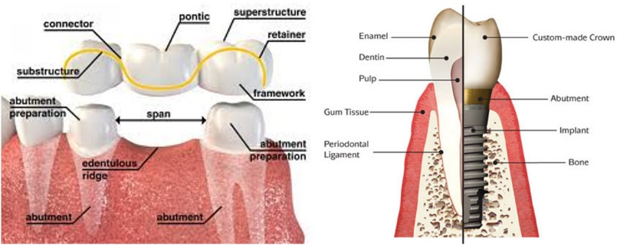

ACCOUNTS RECEIVABLE - Also known as A/R. The amount of outstanding collectible money, whether from a patient or insurance company.

ADA PROCEDURE CODES - The codes by which procedures are classified as established by the American Dental Association (“ADA”). These codes are separated into different categories of treatment. They are also used to file procedures with insurance companies.

ADWORDS – Google AdWords is Google's advertising system in which advertisers bid on certain keywords in order for their clickable ads to appear in Google's search results. Since advertisers have to pay for these clicks, this is how Google makes money from search.

AMALGAM - A metal-based filling.
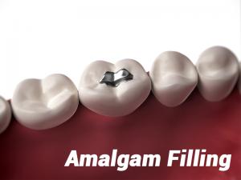
AMALGAM

ANTERIOR - The teeth toward the front of the mouth. They are numbered 6-11 and 22-27.
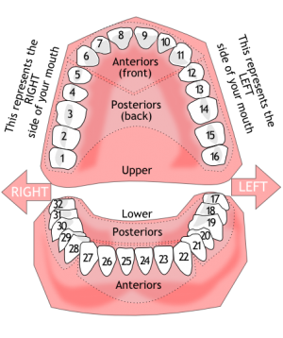
ANTERIOR

ARCHES (UPPER ARCH/LOWER ARCH) - The dental arches are the two arches (crescent arrangements) of teeth, one on each jaw, that together constitute the dentition (which means the arrangement or condition of the teeth in a particular species or individual).

ASSIGNMENT OF BENEFITS - This allows the patient’s benefits to go directly to the provider from the insurance company. The insured must agree to allow this.

ASSOCIATE - Dental associates are non-owner dentists who work in a dental practice. There are usually two arrangements offered to associate doctors – one being an employee of the practice, and the other as an independent contractor.

BASE/BASE PAY - the base rate of pay for a job or activity, excluding additional payments such as overtime or bonuses.

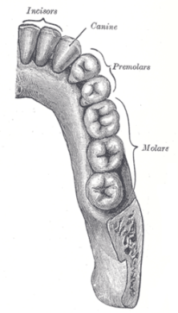
BASIC PROCEDURES - One of the three classifications of insurance coverage. It usually consists of fillings, root canals and periodontal procedures. These procedures are typically covered at about 80% by most insurances, but one must always check before determining benefits.

BICUSPID - Also known as a pre-molar. They are located between the anterior teeth and the molars. The premolar teeth, or bicuspids, are transitional teeth located between the canine cuspid and molar teeth. In humans, there are two premolars per quadrant in the permanent set of teeth, making eight premolars total in the mouth. They have at least two cusps.

BITEWING X-RAYS - Bitewing X-rays show the upper and lower back teeth in a single view. These X-rays are used to check for decay between the teeth and to show how well the upper and lower teeth line up. They also show bone loss when severe gum disease or a dental infection is present. (see next page)
BICUSPIDS (PRE-MOLARS)
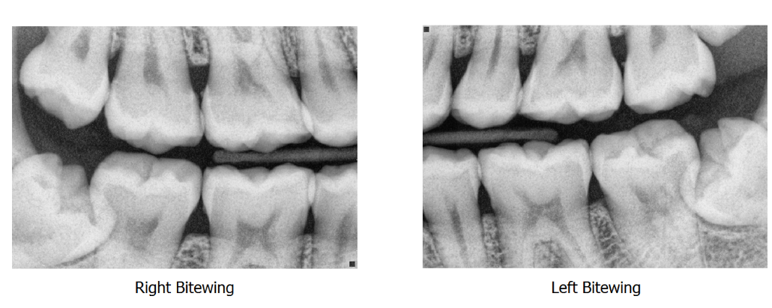
BITEWING X-RAYS

BONDING – A dental procedure in which a dentist applies a tooth-colored resin material (a durable plastic material) and cures it with visible, blue light. This ultimately "bonds" the material to the tooth and improves the overall appearance of teeth.

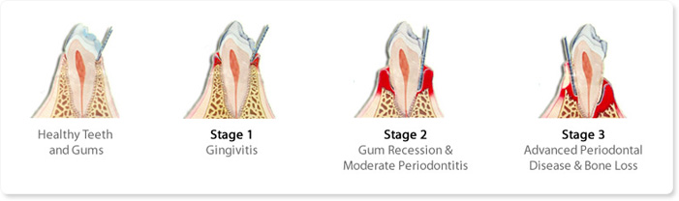
BONE LOSS – Bone loss is the result of untreated periodontal disease. As bacteria spread beyond the gumline – inflammation first known as gingivitis – the disease infects tissue beneath your teeth. A healthy mouth includes bones and teeth surrounded snugly by connective tissue and gum tissue.
BONE LOSS FROM PERIODONTAL DISEASE
BONE LOSS FROM MISSING TEETH
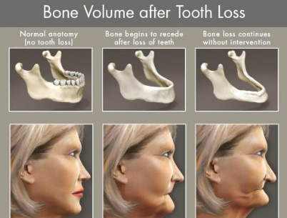
Bone loss can also result from missing teeth. The jawbone is preserved through the pressure and stimulus of chewing. When that is removed through tooth loss, the bone “resorbs” (reabsorbs) into the body. In the first year after tooth extraction 25% of bone is lost, and this bone loss continues on. Excessive bone loss can contribute to a person looking more aged that they truly are.

BRIDGE - A fixed appliance used to replace a missing tooth or teeth.

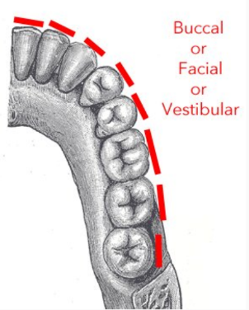
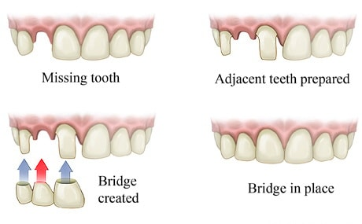
BUCCAL

BUCCAL - The part of the posterior tooth that faces the cheek.

BUILD-UP - Procedure done to add more surface area to a tooth.

BRUXISM – Excessive teeth grinding or jaw clenching unrelated to normal function such as eating or talking.

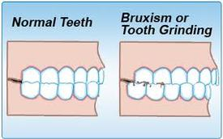

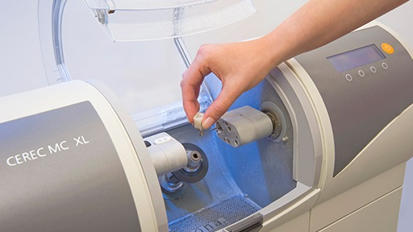
CAD/CAM - This is an acronym for “computer-aided design” / ”computer-aided manufacturing”, which simply means using computer systems to design and manufacture things. CAD/CAM is used in dentistry to produce crowns, bridges, implants, etc. One machine some dentists use is a CEREC machine, which allows an office to produce their own crowns and such in-house (as opposed to using a lab). Such a machine uses CAD/CAM technology to do so.
CAD/CAM CEREC MACHINE

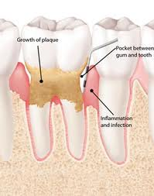
CALCULUS - Hardened plaque that builds up and causes gum disease. Also known as tartar.

CALL TO ACTION - In marketing, a call to action is an instruction to the audience designed to provoke an immediate response, usually using an imperative verb such as "call now", “make an appointment with our new patient special”, "find out more" or "visit a store today".

CANADA PENSION PLAN - The Canada Pension Plan (CPP) is a contributory, earnings-related social insurance program.

CANCELATION - the action of canceling something that has been arranged or planned. In dentistry this is usually when a patient has an appointment that they then call to cancel their hygiene or procedure visit. This is different than a “no-show”, where the person does not call ahead of time and missed their appointment.
CALCULUS

CANINE - Tooth numbers 6, 11, 22 and 27. They are the teeth just in front of the bicuspids.
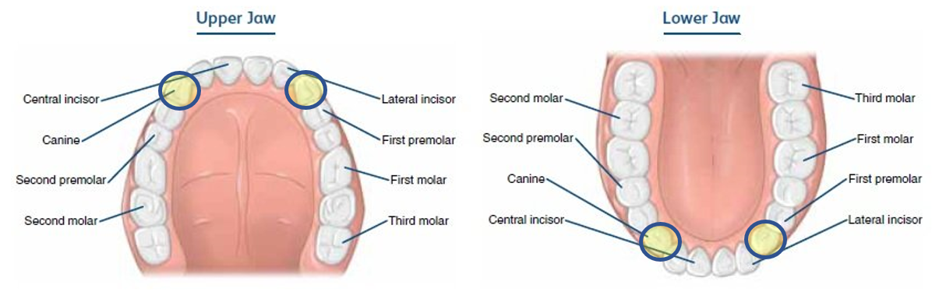

CARIOUS LESIONS – Technical word for a cavity (decayed area on the tooth crown or root).

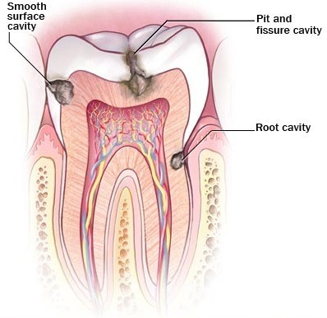
CARIOUS LESIONS (CAVITIES)

CARPULE - A cartridge containing liquid medication to be inserted using a syringe. It is often a tube with a puncturable cap on one end and a sliding plug on the other end.
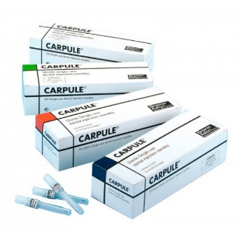
CASE PRESENTATION - The process of telling a patient the treatment he or she requires. This would include outlining diagnosis, proposed dental treatment, alternative treatments, risks, costs and responsibilities.

CASH PATIENT - A patient without insurance coverage.

CAST POST - A procedure done to stabilize a tooth.
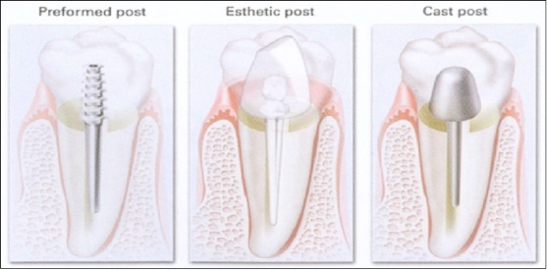
CAST POST

CE – Continuing Education. See CONTINUING EDUCATION.

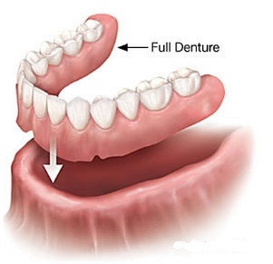
COLLECTION PERCENTAGE - The amount of treatment dollars produced that is collected. It is calculated by dividing $ collected by $ produced.

COMPLETE DENTURE - A removable prosthesis used to replace all of the teeth in one or both jaws. Also known as a full denture.
COMPLETE DENTURE
COMPLEX (SURGICAL) EXTRACTION - An extraction that requires surgery and sutures.

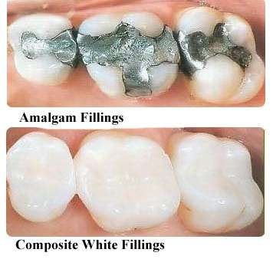
COMPOSITE - A glass-based resin filling that can be made to match the natural color of the tooth.

CONSULTATION (or CONSULT) - a diagnostic service provided by a dentist where the dentist, patient, or other parties (e.g., another dentist, physician, etc.) discuss the patient's dental needs and proposed treatment.
COMPOSITE

CONTINUING EDUCATION / CE CREDITS - A continuing education unit (CEU) or continuing education credit (CEC) is a measure used in continuing education programs to assist the professional to maintain his or her license in their profession. Continuing education is required of many professionals after they have left the formal education system, consisting typically of short or part-time courses. In dentistry, this applies to a dentist, a Registered Dental Hygienist (“RDH”) and a Registered Dental Assistant (“RDA”). Difference states have different requirements

Coordination of Benefits. (“COB”) – A term used when a patient is covered by more than one insurance. The benefits are coordinated between the primary and then, the secondary insurance company.

CO-PAYMENT - The patient’s out-of-pocket expense after the insurance benefits have been taken into account.

CO-SIGN – The act of signing for another person's debt which involves a legal obligation made by the cosigner to make payment on the other person's debt should that person default.

COSMETIC DENTISTRY - Dentistry done purely to improve the look of a patient’s teeth or smile. A dentist can reshape teeth, close spaces, restore worn or short teeth or alter the length of teeth. Common procedures include bleaching, bonding, crowns, veneers and reshaping and contouring.

COVERAGE – the amount of protection given by an insurance policy.

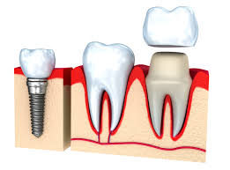
CPA (Certified Public Accountant) - an accountant certified by a state examining board as having fulfilled the requirements of state law to be a public accountant.

CROWN - 1. The part of the tooth that is visible in the mouth. 2. A restoration that covers the entire top of the tooth; usually gold or tooth colored material. Also called a cap.

CROWN
curettage – The removal of inflamed soft tissue lateral to the pocket wall.
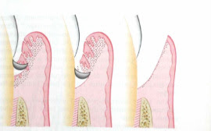
CURETTAGE

CUSTOMER SERVICE - All interactions between a customer and a product provider before, during, and after the time of sale or delivery or a product or service.

DECIDUOUS TEETH – “Deciduous” means “temporary”, as of trees that lose their leaves in the fall. In dentistry, these are temporary teeth, otherwise known as “baby teeth”.
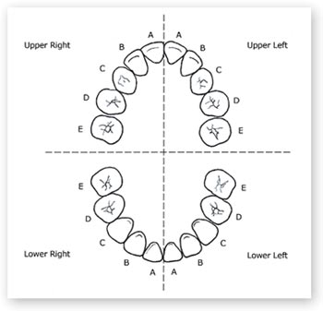
BABY TEETH CHART
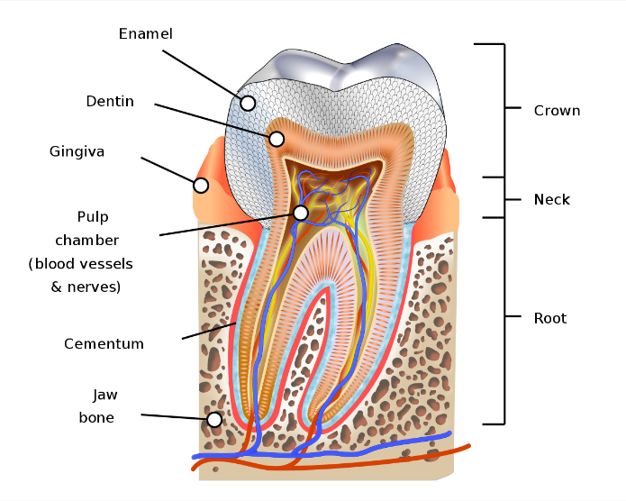
DEDUCTIBLE - The deductible is an amount decided by the insurance company that has to be met by the patient before the insurance company will start paying its percentage. Deductibles vary from one insurance policy to the next.

DELEGATE – entrust (a task or responsibility) to another person, typically one who is less senior than oneself.

DENTIN – The hard, dense, bony tissue forming the bulk of a tooth beneath the enamel.
DENTIN

DENTURE - a removable plate or frame holding one or more artificial teeth.
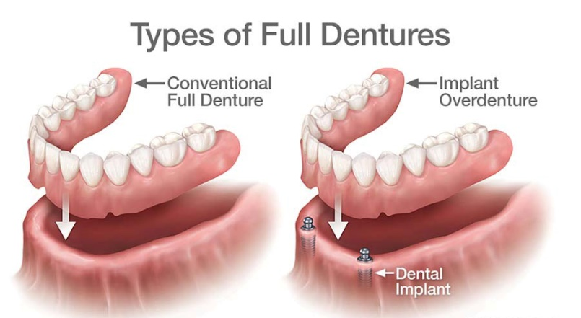

DENTURE IMPRESSION – A dental impression is a negative imprint of hard (teeth) and soft tissues in the mouth from which a positive reproduction (cast or model) can be formed. It is made by placing an appropriate material in a stock or custom dental impression tray which is designed to roughly fit over the dental arches.

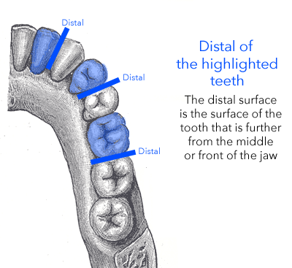
DIAGNOSTIC MODELS - The models made to determine the best course of treatment. They are made from impressions taken from the patient’s natural teeth. Also known as Study Models.

DISTAL - The part of the teeth facing the back of the mouth.

Distobuccal – Relating to or located on the distal and buccal surfaces of a molar or premolar.

DOS - Date of Service. This is the actual date in which the service is rendered.
DISTAL

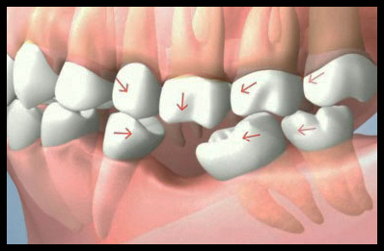
DRIFTING – A drifting tooth is a tooth that migrates from its normal position. When a single tooth is lost, and is not immediately replaced, the surrounding bone will begin to resorb or shrink in the empty space, because it is no longer stimulated by the tooth’s roots. With no adjacent support, the neighboring teeth begin to drift toward the area of the missing tooth.

EFFECTIVE DATE - The date that an insurance policy goes into effect.
DRIFTING

ENDODONTICS - Dental specialty which deals with the diagnosis and treatment of the pulp; the tissue within the tooth and the root canals (from the Greek roots endo- "inside" and odont- "tooth").

EOB - Explanation of Benefits. This is a statement which accompanies the insurance payment, explaining what was paid and why.

EXPANDED FUNCTIONS ASSISTANT - Dental Assistant Qualified in or to perform expanded duties/functions, take x-rays, monitor nitrous oxide administration, coronal polishing, apply sealants, supervision, CPR certification, and completion of approved coursework. Some states allow placement of fillings. Various states have various allowances and restrictions.

FEE-FOR-SERVICE – A method in which doctors and other health care providers are paid for each service performed.

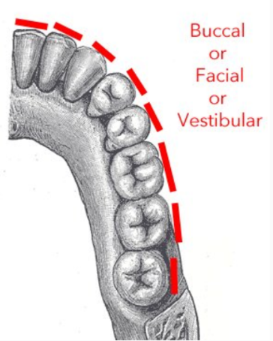
F.I.C.A. - The Federal Insurance Contributions Act (FICA) is the federal law that requires you to withhold two separate taxes from the wages you earn. It includes Social Security Tax and Medicare Tax at a flat percentage rate. The Social Security Tax is 6.2% rate of your wages, and the Medicare Tax is 1.45% of your wages. If you earn more than $200,000, you will also be taxed an additional 0.9% Medicare surtax.

FINANCING – provide funding for (such as CareCredit or similar).

EXTRACTION - The removal of a tooth.
FACIAL
FACIAL - The surface of the anterior teeth facing the cheek.

FINANCIAL ARRANGEMENT - FA. The arrangement made with a patient for payment.

FLOW - To proceed steadily, smoothly, evenly. To have a smooth, uninterrupted continuity. A “flow line” represents the path in which something would take across various steps. A “flow chart” would be a visual representation of how a product, person or thing progresses through various necessary, agreed-upon steps in an organization as per that organization’s policy.

FLUORIDE - A treatment intended to strengthen the natural tooth.

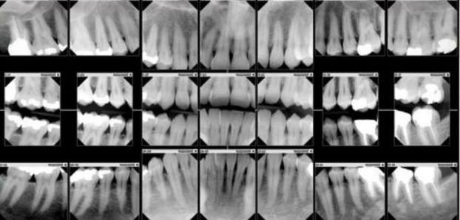
FULL MOUTH X-RAY - Usually 14 periapical x-rays and 4 bitewings. The x-rays, when put together in order, give a detailed picture of the teeth and bone surrounding the teeth.

GINGIVA - The gums.

GINGIVAL GRAFT – See GUM GRAFT.
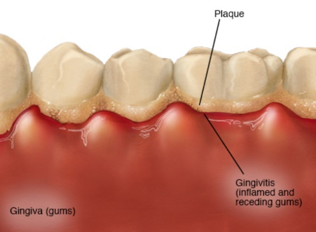
GINGIVITIS
GINGIVITIS - A slight infection of the gum tissue. One of the first signs of gum disease.

GOOGLE ADWORDS – Google AdWords is Google's advertising system in which advertisers bid on certain keywords in order for their clickable ads to appear in Google's search results. Since advertisers have to pay for these clicks, this is how Google makes money from search.

GUM DISEASE – See PERIODONTAL DISEASE.
GUM GRAFT
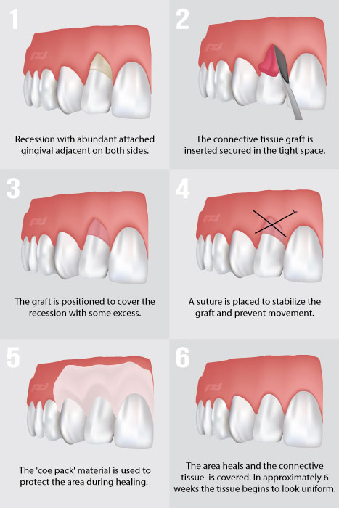
GUM GRAFT – A gingival graft, also called gum graft or periodontal plastic surgery, is a generic name for any of a number of periodontal surgical procedures in which the gum tissue is grafted. The aim may be to cover exposed root surfaces or merely to augment the gum tissue.

HIPAA - (Health Insurance Portability and Accountability Act of 1996) is United States legislation that provides data privacy and security provisions for safeguarding medical information.

HMO - short for health maintenance organization. A health insurance organization to which subscribers pay a predetermined fee in return for a range of medical services from physicians and healthcare workers registered with the organization.

HUMAN RESOURCES - the department of a business or organization that deals with the hiring, administration, and training of personnel.

HYGIENIST – a dental care provider specializing in scaling and polishing teeth and in giving advice on cleaning the teeth.

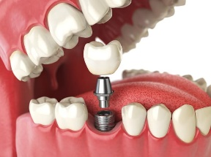
IMMEDIATE DENTURE - A complete denture placed at the time of extraction of the teeth. An “immediate denture” allows a patient to have their dentures immediately (as opposed to waiting weeks for conventional dentures). They are generally worn 6 to 12 months, and usually cost more.

IMPLANT - A procedure done to replace a tooth without having to attach it to another. It has its own prosthetic root and crown.
IMPLANT
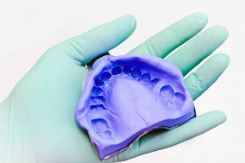
IMPRESSION
IMPRESSION - A mold taken of the existing teeth. Diagnostic models are made from an impression.

IMPRESSION MATERIAL – Material used for a dental impression.
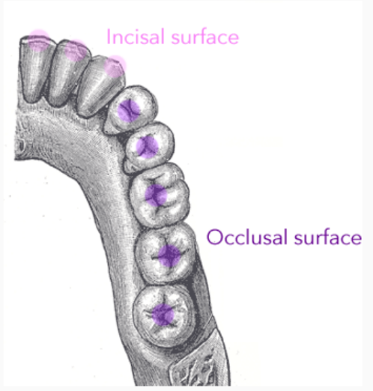
INCISAL - The biting edge of incisors.

INCISOR - The front teeth. These are narrow-edged teeth at the front of the mouth. Tooth numbers 7-10 and 23-26.
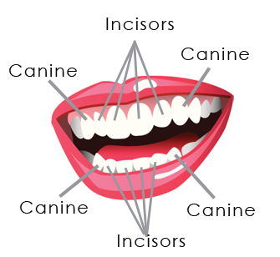
INCISAL
INITIAL EXAM - An exam done on a patient the first time he or she is seen in an office.

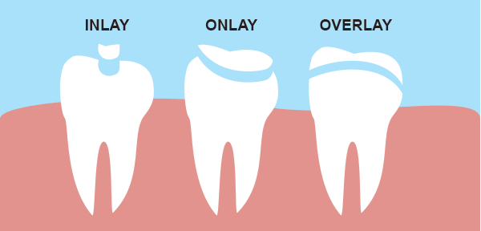
INLAY - A permanent, lab-created restoration made from composite or porcelain material.

“IN NETWORK” - In network refers to providers or health care facilities that are part of a health plan's network of providers with which it has negotiated a discount.
INLAY

INS. – An abbreviation commonly meaning “Insurance”.

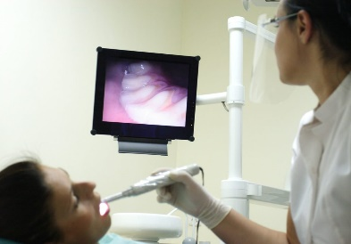
INTRAORAL PHOTOGRAPHY/INTRAORAL CAMERA - Intraoral cameras (“IOVs”) are cameras used by dentists or doctors to show a patient the interior of their mouth, as an alternative to using a mirror. They were first introduced in 1989 and are now widely used in dental offices. Intraoral cameras allow the patient to see a clear picture of the inside of their mouth, aiding the dentist in consulting with them on various treatment options. Images can be saved to a patient's file for future reference.

IP Address - The Internet Protocol (IP) is the method or protocol by which data is sent from one computer to another on the Internet. Each computer (known as a host) on the Internet has at least one IP address that uniquely identifies it from all other computers on the Internet.

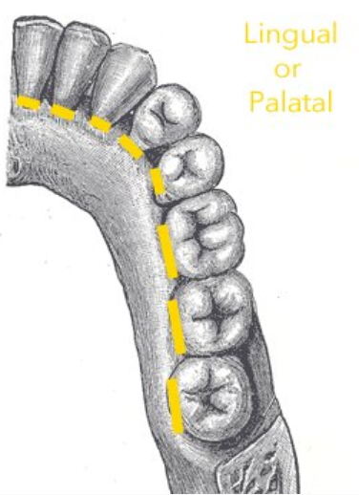
LINGUAL - the surface of the tooth that lies along the tongue.

MAJOR PROCEDURES - One of the three classifications of insurance coverage. It usually consists of crowns, bridges, dentures. These procedures are usually covered at 50% with most insurances, but one would always verify this before determining benefits.

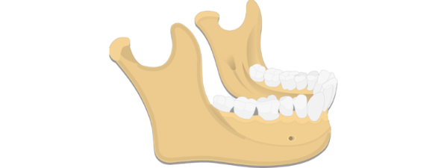
MANAGED CARE – a system of health care in which patients agree to visit only certain doctors and hospitals, and in which the cost of treatment is monitored by a managing company.
LINGUAL
MANDIBLE
MANDIBLE - The lower jaw.

MARKETING - the action or business of promoting and selling products or services, including market research and advertising.
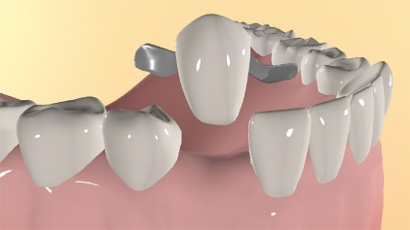
MARYLAND BRIDGE - A bridge done to replace a missing tooth using “wings” attached to the lingual surface of adjacent teeth instead of using abutments.
MAXILLA
MAXILLA - The upper jaw.
MARYLAND BRIDGE

MEDICAID - Medicaid is a state and federal program that provides health coverage if you have a very low income. Medicaid is a jointly funded, Federal-State health insurance program for low-income and needy people. It covers children, the aged, blind, and/or disabled and other people who are eligible to receive federally assisted income maintenance payments.

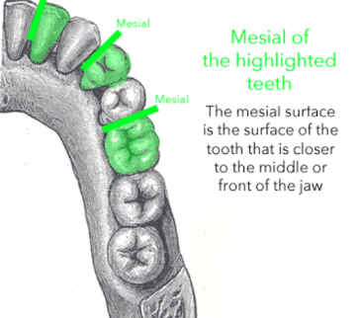
MEDI-CAL – The California Medical Assistance Program (Medi-Cal or MediCal) is California's Medicaid program serving low-income individuals, including families, seniors, persons with disabilities, children in foster care, pregnant women, and childless adults with incomes below 138% of federal poverty level.

MEDICARE – Medicare is the federal insurance program for Americans age 65 and over (it also covers the disabled). Medicare is funded by the Social Security Administration.

MESIAL - The part of the tooth facing the center of the mouth.
MESIAL

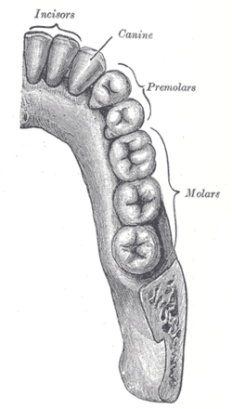
MOLAR - The largest of the teeth in the back of the mouth used for grinding.

NEBULOUS - unclear, vague, or ill-defined.

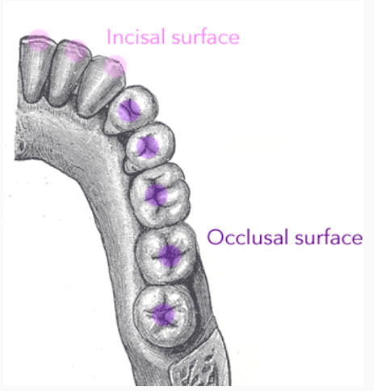
NEGATIVE KEYWORDS – See Google Adwords above. For example, when you add "free" as a negative keyword to your campaign or ad group, you tell AdWords not to show your ad for any search containing the term "free." On the Display Network, your ad is less likely to appear on a site when your negative keywords match the site's content.
MOLARS

NITROUS OXIDE - Also known as laughing gas. The gas used to calm nervous patients. It is mixed with oxygen and the patient breathes it during the procedure.

NO-SHOW - a person who has made a reservation, booking, or appointment but neither keeps nor cancels it.
OCCLUSAL
OCCLUSAL - The biting surface of the tooth.

ONLAY - A permanent, lab-created restoration made from composite or porcelain material. The difference between an inlay and an onlay is that an onlay includes a cusp of the tooth.
ONLAY

ONLINE PRESENCE - An online presence is any existence of an individual or business that can be found via an online search. This is comprised of one’s website, ability to be found through search engines (such as Google, Bing, Yahoo, etc.), YouTube, Facebook, Instagram, LinkedIn, Twitter, etc.

OPEN ACCOUNT - When there is a balance on a patient's account that is owed by the patient or the insurance company. Any account that does not have a -0- balance (or a credit balance).

OPERATIVE - An appointment where restorations are done.
OPERATORY
OPERATORY - The room in which treatment is done.

ORAL SURGERY- Treatment related to extractions or the repair of an area due to the loss of a tooth, usually involving the jaw.

ORTHODONTICS - The specialty which deals with the prevention, correction and/or treatment of misalignment of the teeth and jaws.

OVERHEAD – the general, fixed cost of running a business, as rent, lighting, and heating expenses, which cannot be charged or attributed to a specific product or part of the work operation.

PALLIATIVE TREATMENT - Treatment done to immediately relieve pain, usually done on an emergency basis. Palliative means relieving pain without dealing with the cause of the condition.

P & L - A profit and loss statement (P&L) is a financial statement that summarizes the revenues, costs and expenses incurred during a specific period of time, usually a fiscal quarter or year.
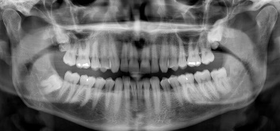
PANORAMIC X-RAY - A single film showing, in one view, all of the teeth and the surrounding structure of the mouth and jaws.
PANORAMIC X-RAY
PARTIAL DENTURE - A removable appliance used to replace one or more missing teeth in the same jaw.
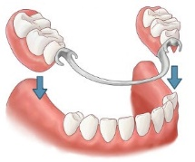
PARTIAL DENTURE
PAT ANSWER – Something that seems learned, mastered or memorized exactly, as if from a script.

PAY-PER-CLICK - (in online marketing) a business model whereby a company that has placed an advertisement on a website pays a sum of money to the host website when a user clicks on to the advertisement. This could be with Google Adwords, or now with Facebook advertising.

PAYROLL - the total amount of wages and salaries paid by a company to its employees.

PAYROLL TAXES - Payroll taxes are taxes imposed on employers or employees, and are usually calculated as a percentage of the salaries that employers pay their staff

PAY STRUCTURE - A pay structure (or salary structure) is a hierarchal group of jobs and salary ranges within an organization. Salary structures often are expressed as pay grades or job grades that reflect the value of a job in the external market and/or the internal value to an organization.

PEDODONTICS - That dental specialty dealing with the diagnosis, treatment and prevention of dental disorders in children.

PER DIEM - for each day (used in financial contexts).

PERIAPICAL RADIOLUCENCY – Dark lesions around the roots of the teeth, shown on an xray, are known as “periapical radiolucencies”. Periapical means encompassing or surrounding the tip of the root of a tooth. A radiolucency often is a void or an area of tissue that is less dense. Some radiolucencies are normal and others are abnormal, such as radiolucencies that can be seen around the roots of the teeth.

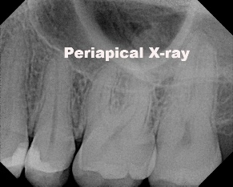
PERIAPICAL X-RAY - An x-ray the focuses on a specific tooth or teeth and show the entire tooth, from the exposed crown to the end of the root and the bones that support the tooth. These X-rays are used to find dental problems below the gum line or in the jaw, such as impacted teeth, abscesses, cysts, tumors, and bone changes linked to some diseases. PERIAPICAL means “of, relating to, occurring in, affecting, or being the tissues surrounding the apex of the root of a tooth”.
PERIAPICAL X-RAY

PERIODONTAL CHARTING - The process of measuring the distance from the gums to the supporting bone underneath.
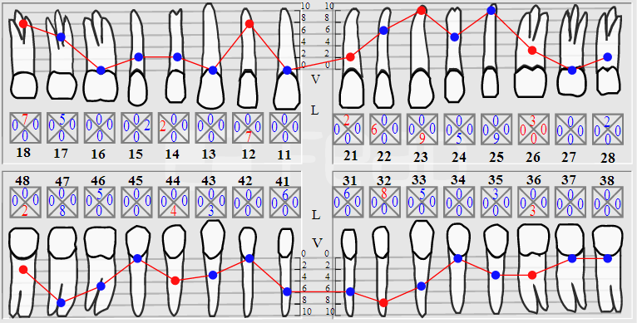

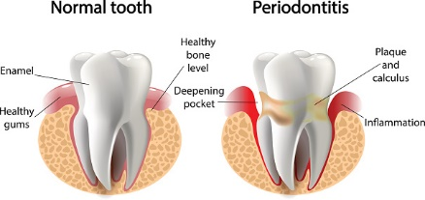
PERIODONTAL DISEASE - A chronic inflammation of the gums with pus formation and bleeding. Also known as pyorrhea. It is the main cause of tooth loss.

PERIODONTAL MAINTENANCE - The regular cleanings performed on a patient that has had treatment for periodontal disease.

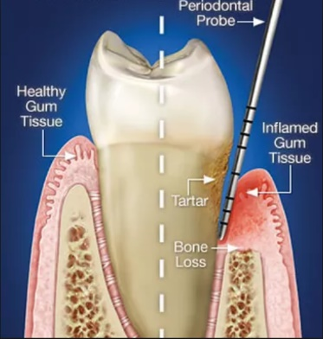
PERIODONTAL PROBING - A periodontal probe is an instrument in dentistry commonly used in dental exams. It is usually long, thin, and blunted at the end. The primary purpose of a periodontal probe is to measure pocket depths around a tooth in order to establish the state of health of the periodontium (which is the specialized tissues that both surround and support the teeth, maintaining them in the jaw bones). PERIODONTAL PROBING is a clinical procedure that allows the clinician to estimate the structural status of the periodontal tissues by mechanically probing the natural space found between the tooth and the gum tissue that surrounds the tooth (known as the free gingiva). Probing depth allows the clinician to make certain assumptions about the state of health of the periodontium. See SCALING AND ROOT PLANING for more information on how this is handled.
PERIODONTAL PROBING

PERIODONTAL SCALING - A procedure performed that deep cleans under the gums to remove plaque and begin treating gum infection.

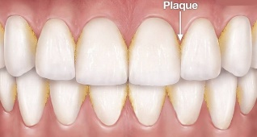
PERIODONTAL THERAPY – Care intended to preserve natural dentition, periodontium, and preimplant tissues and to maintain and improve the health of these tissues.
PLAQUE
PLAQUE - The sticky film of food and bacteria that builds up on the teeth.

PONTIC - In a fixed bridge the tooth or teeth being replaced. They are permanently connected to the abutments.
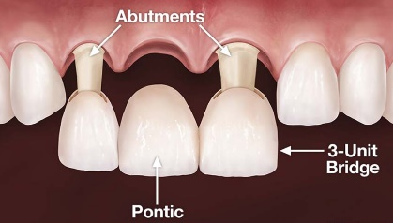
PONTIC
POSTERIOR - The back teeth.

PPO (PREFERRED PROVIDER ORGANIZATION) – In health insurance in the United States, a preferred provider organization (or PPO, sometimes referred to as a participating provider organization or preferred provider option) is a managed care organization of medical doctors, hospitals, and other health care providers who have agreed with an insurer or a third-party administrator to provide health care at reduced rates to the insurer's or administrator's clients.

PRE-DETERMINATION/ PRE-ESTIMATE - The pre-authorizing of a claim. The claim is sent in before the procedure is done to determine the approximate amount of coverage for a procedure. A pre-determination is an estimate of what treatment a patient’s dental plan will cover and what the patient will be responsible for. The dental office will submit an outline of the proposed treatment to the patient’s dental plan provider prior to proceeding with treatment. It is an estimate only and does not guarantee the final costs the patient will be responsible for paying.

PRE-MED - Medication needing to be taken before treatment.

PREVENTATIVE PROCEDURES - One of the three classifications of insurance coverage. It usually consists of cleanings, exams and x-rays. These procedures are usually covered at 80% - 100%, but one would always verify this before determining benefits.

PRIMARY INSURANCE - The patient’s main insurance company. If the person has more than one insurance policy this is the one that is filed first, usually as determined by the Birthday Rule. The Birthday Rule is a term used by the health insurance industry to determine coverage for children whose parents have different plans. The basic understanding of this rule is pretty simple, however it can get somewhat more complicated under various circumstances.

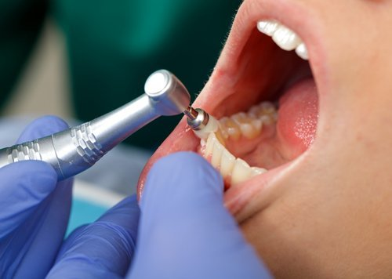
PROPHYLAXIS - “Prophy.” The professional cleaning of the teeth to remove all accumulated plaque, light calculus and stains. It is performed in cases where no periodontal disease exists.

PROSTHODONTICS - The dental specialty which deals with the replacement of missing teeth and supporting dental structures with crowns, bridgework, partials, dentures or implants.
PROPHYLAXIS

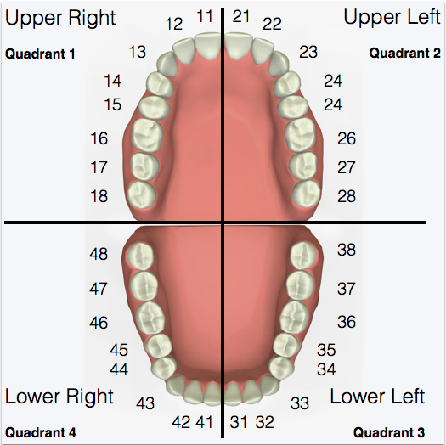
PROVINCIAL HEALTH INSURANCE - Health insurance in Canada is handled by individual provinces and territories. New residents to a particular province must apply for health coverage. Upon being granted health coverage, a health card is issued which provides coverage in that particular province or territory.

PURPOSE - To have the intention of doing or accomplishing (something); intend; aim. (Funk and Wagnalls Standard Dictionary).

PUBLIC RELATIONS - the maintenance of a favorable public image by a company or organization.

QUADRANTS - The division of the mouth into four equal parts.
QUADRANTS
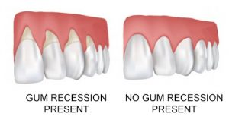
REBATE - a partial refund to someone who has paid too much money for tax, rent, or a utility.

RECALL - A term used to indicate an office visit for a patient who is coming in for his/her regular, usually 3 or 6-month, cleaning and check-up.

RECESSION - The measurable amount of gum loss along the crown of a tooth.

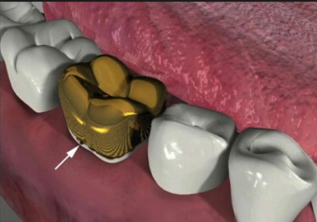
RECURRENT DECAY - The decay that is present around an existing restoration.
RECURRENT DECAY

REFERRAL – an act of referring someone or something for consultation, review, or further action.

RESPONSIBLE PARTY - The person responsible for the payment of a bill.

RESTORATIVE DENTISTRY – Restorative dentistry is the study, diagnosis and integrated management of diseases of the teeth and their supporting structures and the rehabilitation of the dentition to functional and aesthetic requirements of the individual.

RESTORATION - Restoration is a term used in dentistry to describe restoring the function of the tooth by replacing missing or damaged tooth structure.

RETURN ON INVESTMENT - is performance measure used to evaluate the efficiency of investment. It compares the magnitude and timing of gains from investment directly to the magnitude and timing of investment costs. It is one of most commonly used approaches for evaluating the financial consequences of business investments, decisions, or actions.

ROOT CANAL THERAPY (“RCT”) – An endodontic treatment where the pulp (nerve) of the tooth is removed and the canals cleaned due to the nerve being infected and/or dead. The infected tissue is removed, the canals are cleaned, the canals are then filled with a permanent material (such as gutta-percha, which is a hard, tough substance that is a rubber/latex material gotten from trees), the opening sealed and a crown is then cemented onto the rebuilt tooth.
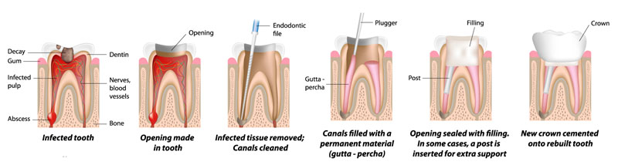

ROUTING - To dispatch or send by a certain way. (Funk and Wagnalls Standard Dictionary)

SCALING AND ROOT PLANING - Scaling and root planing, also known as conventional periodontal therapy, non-surgical periodontal therapy, or deep cleaning, is a procedure involving removal of dental plaque and calculus (scaling) and then smoothing, or “planning”, of the (exposed) surfaces of the roots that is saturated with calculus, toxins, or microorganisms – the things which cause inflammation.
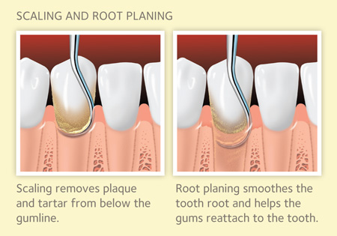

SEALANT - A thin plastic coating bonded to the occlusal grooves of the teeth, usually in children, for the purpose of preventing decay.
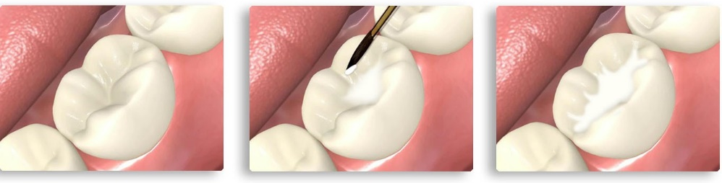

SEARCH ENGINE – A search engine is really a general class of programs; however, the term is often used to specifically describe systems like Google, Bing and Yahoo! Search that enable users to search for documents on the web.

SEARCH ENGINE OPTIMIZATION – Search Engine Optimization, or S.E.O., is the process of maximizing the number of visitors to a particular website by ensuring that the site appears high on the list of results returned by a search engine. The key to getting more traffic lies in integrating content with search engine optimization and social media marketing.

SECONDARY INSURANCE - An insurance policy that a patient has other than his or her primary insurance. This is usually a spouse’s insurance coverage when the patient has his or her own policy.

SIMPLE EXTRACTION - An extraction done without surgery or sutures.

SIX-HANDED-DENTISTRY - A technique in which two dental assistants or a dental assistant & dental hygienist works directly with the dentist on the procedures being done in the mouth of a patient. The technique reduces fatigue and improves the effectiveness of dental procedures. More common is “four-handed-dentistry”, which simply means that the dental assistant's two hands are assisting the dentist's two hands, helping to reduce the amount of time a dental exam or procedure may take.

SOCIAL MEDIA - Websites and applications that enable users to create and share content or to participate in social networking. This includes platforms such as Facebook, YouTube, Twitter, Instagram, LinkedIn, etc.

SOF - Signature On File. Most insurance companies will allow assignment of benefits to the provider with SOF on the claim as long as a patient has signed an assignment of benefits form in the office.

STATE DENTAL PRACTICE ACT – A Dental Practice Act specifies the legal requirements for the practice of dentistry within each state. An administrative board, usually called the Board of Dentistry, interprets and implements state regulations.

STATISTICS/STATS – a collection of quantitative data measuring the change in quantity of the same thing over different periods of time.

STUDY MODELS - See Diagnostic Models.

SUPRAERUPTION – Supraeruption occurs when a tooth continues to grow out of the gum if the opposing tooth in the opposite jaw is missing. Treatment involves placing a tooth in the missing space and adjusting the height of the supra-erupted tooth.
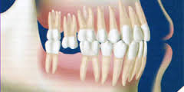
SUPRAERUPTION
SURTAX - an additional tax on something already taxed, such as a higher rate of tax on incomes above a certain level.
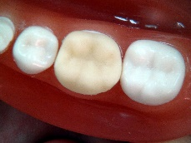
TEMPORARY CROWN
TEMPORARY CROWN - A crown made in the office that protects the tooth once it is prepared for the permanent crown, cemented to the tooth with a temporary bonding agent. When the permanent crown has arrived, the dentist removes the temporary crown and fits the permanent crown in its place.

THIRD PARTY FINANCING – The financing comes from a third party, usually a financial institution or other investor, which is not the dentist or patient. Third party financing in dentistry includes CareCredit and similar credit institutions.

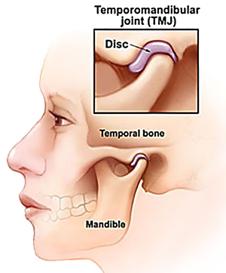
TMJ - Temporomandibular Joint. The jaw joint located just in front of the ear on either side of the face.

TMJ DISFUNCTION - Any number of abnormal or disease processes which affect the temporomandibular joint.

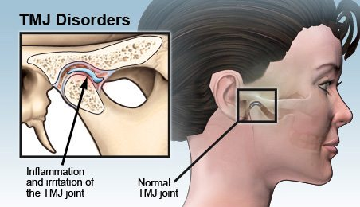

TOOTH NUMBER - Each tooth has a corresponding number, 1-32, starting with the Wisdom Tooth on the top right and ending with the Wisdom Tooth on bottom right.
TOOTH NUMBERS

TREATMENT COORDNATOR - A Treatment Coordinator is a sales (case acceptance) position. A treatment coordinator closes or assists in closing the treatment plans generated by the doctor. They take responsibility for the entire patient base and work toward having no patients with incomplete treatment plans.

TREATMENT PLAN - a schedule of procedures and appointments designed to restore, step by step, a patient's oral health. The plan contains the advantages, disadvantages, costs, alternatives, and sequelae of treatment.

TREATMENT ROOM – See OPERATORY.
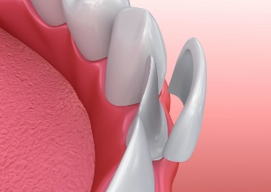
VENEER - Porcelain material bonded to the facial surfaces of anterior teeth for cosmetic purposes.

WALK-IN - A patient who comes into the office without a scheduled appointment. He just "walks in".
VENEER

WISDOM TOOTH - Any one of the last molars in the mouth. Also known as 3rd molars. These may or may not come in through the gums and when there is insufficient room for them, they may become “impacted”. Impacted wisdom teeth (or impacted third molars) are wisdom teeth which do not fully erupt into the mouth because of blockage from other teeth (impaction). If the wisdom teeth do not have an open connection to the mouth, pain can develop with the onset of inflammation or infection or damage to the adjacent teeth.
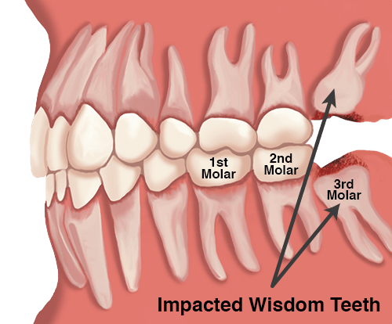

YEARLY MAXIMUM BENEFITS - The maximum amount that an insurance company will pay for a patient’s treatment during a policy year.

